1. use one-way data binding for read-only data.
2. Our final application looks like,

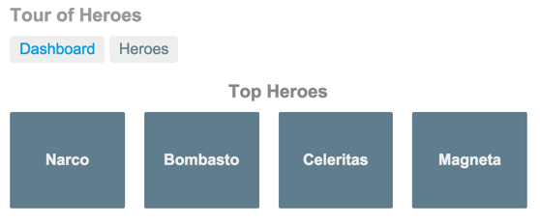

1. You can click the two links above the dashboard ("Dashboard" and "Heroes") to navigate between this Dashboard view and a Heroes view.
2. If you click the dashboard hero "Magneta," the router opens a "**Hero Details**" view where you can change the hero's name.

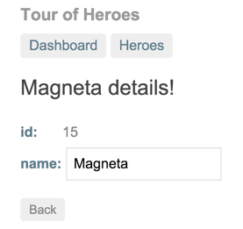

1. Clicking the "Back" button returns you to the Dashboard. Links at the top take you to either of the main views. If you click "Heroes," the app displays the "Heroes" master list view.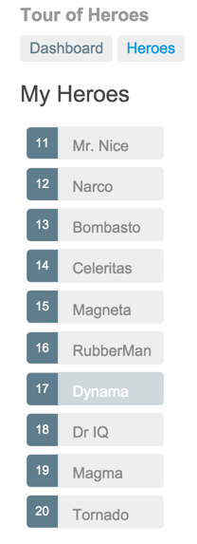
2. When you click a different hero name, the read-only mini detail beneath the list reflects the new choice.

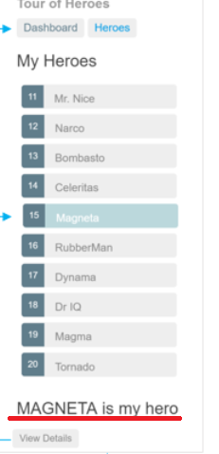

1. You can click the "View Details" button to drill into the editable details of the selected hero.

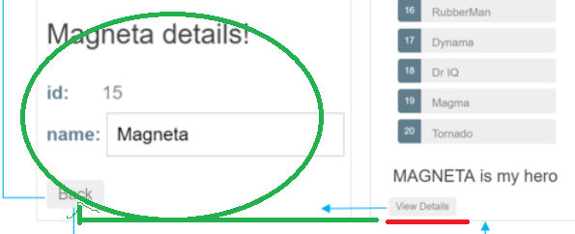

1. The following diagram captures all of the navigation options.

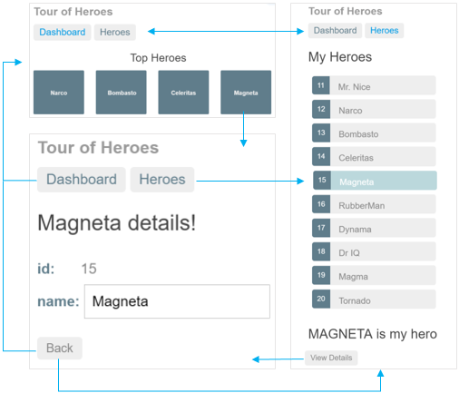

1. The file structure should look like this:

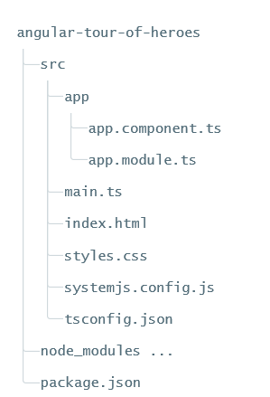

1. 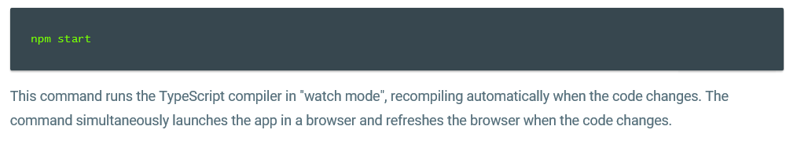
2. The double curly braces are Angular's interpolation binding syntax.
3. Property binding helps show app data in the UI
4. The template is a multi-line string within ECMAScript 2015 backticks (`). The backtick (`)—which is not the same character as a single quote (')—allows you to compose a string over several lines, which makes the HTML more readable
5. 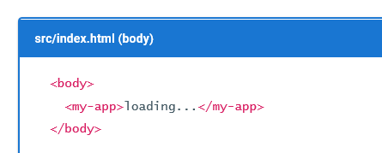🡺

When you bootstrap with the AppComponent class (in main.ts), Angular looks for a <my-app> in the index.html, finds it, instantiates an instance of AppComponent, and renders it inside the <my-app> tag.

1. Template inline or template file? 🡺 You can store your component's template in one of two places. You can define it inline using the template property, or you can define the template in a separate HTML file and link to it in the component metadata using the @Component decorator's templateUrl property.
2. 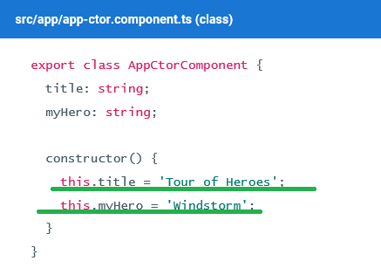
3. 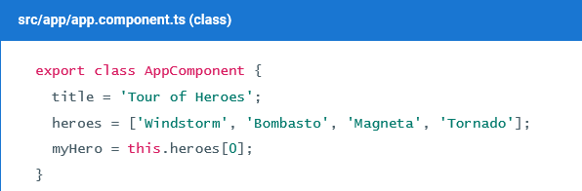

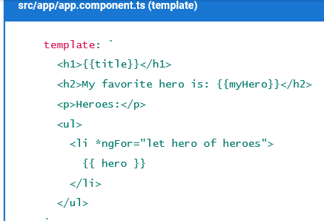

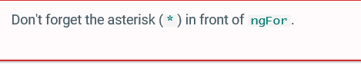

1. 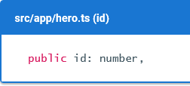
2. 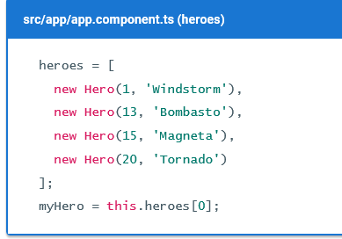
3. 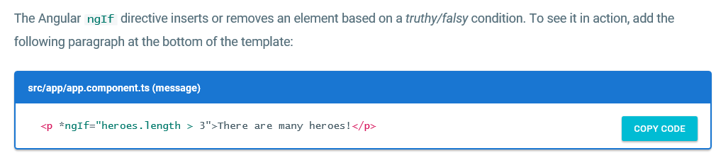
4. Don't forget the leading asterisk (*) in *ngIf.
5. 